附件5

[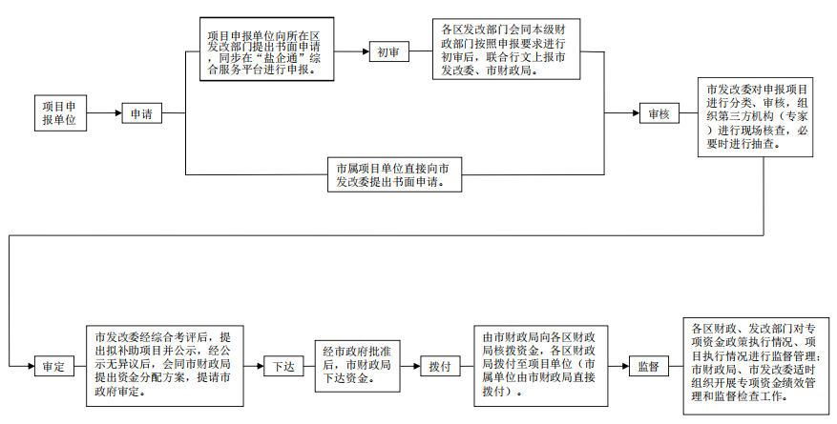](https://czj.yancheng.gov.cn/picture/0/2fa41af43afe4641a28e55b8ea1cd839.png)