附件2
2025年3月31日世界知识产权组织国际局通报的
15件政府间国际组织徽记、名称、名称缩写等徽记

序号 | 国际局编号 | 组织 | 地址 | 类别 | 标志
1 | QO2517 | OrganizationTranslation Centre for the Bodies of the European Union (英语)  Centre de traduction des organes de l'Union Européenne (法语)  Centro de traducción de los órganos de la Unión Europea (西班牙语) | European Commission CDMA 05/181  Brussels  1049  Belgium | 徽记 | 
2 | QO2518 | Translation Centre for the Bodies of the European Union (英语)  Centre de traduction des organes de l'Union Européenne (法语)  Centro de traducción de los órganos de la Unión Europea (西班牙语) | European Commission CDMA 05/181  Brussels  1049  Belgium | 名称 | Център за преводи за органите на Европейския съюз
3 | QO2519 | Translation Centre for the Bodies of the European Union (英语)  Centre de traduction des organes de l'Union Européenne (法语)  Centro de traducción de los órganos de la Unión Europea (西班牙语) | European Commission CDMA 05/181  Brussels  1049  Belgium | 名称 | Ionad Aistriúcháin Chomhlachtaí an Aontais Eorpaigh
4 | QO2520 | Translation Centre for the Bodies of the European Union (英语)  Centre de traduction des organes de l'Union Européenne (法语)  Centro de traducción de los órganos de la Unión Europea (西班牙语) | European Commission CDMA 05/181  Brussels  1049  Belgium | 名称 | Prevoditeljski centar za tijela Europske unije
5 | QO2521 | Translation Centre for the Bodies of the European Union (英语)  Centre de traduction des organes de l'Union Européenne (法语)  Centro de traducción de los órganos de la Unión Europea (西班牙语) | European Commission CDMA 05/181  Brussels  1049  Belgium | 名称 | Centrul de Traduceri pentru Organismele Uniunii Europene
6 | QO2522 | Joint Institute for Nuclear Research (英语) | 6, Joliot-Curie St Dubna  141980  Russian Federation | 徽记 | 
7 | QO2523 | Joint Institute for Nuclear Research (英语) | 6, Joliot-Curie St Dubna  141980  Russian Federation | 徽记 | 
8 | QO2524 | Joint Institute for Nuclear Research (英语) | 6, Joliot-Curie St Dubna  141980  Russian Federation | 旗帜 | 
9 | QO2525 | Joint Institute for Nuclear Research (英语) | 6, Joliot-Curie St Dubna  141980  Russian Federation | 名称 | JOINT INSTITUTE FOR NUCLEAR RESEARCH
10 | QO2526 | Joint Institute for Nuclear Research (英语) | 6, Joliot-Curie St Dubna  141980  Russian Federation | 名称 | ОБЪЕДИНЕННЫЙ ИНСТИТУТ ЯДЕРНЫХ ИССЛЕДОВАНИЙ
11 | QO2527 | Joint Institute for Nuclear Research (英语) | 6, Joliot-Curie St Dubna  141980  Russian Federation | 名称缩写 | JINR
12 | QO2528 | Joint Institute for Nuclear Research (英语) | 6, Joliot-Curie St  Dubna  141980  Russian Federation | 名称缩写 | ОИЯИ
13 | QO2529 | International Civil Defence Organization (英语)  Organisation internationale de protection civile (法语) | Chemin de Surville 10-12  Petit Lancy  1213  Switzerland | 徽记 | 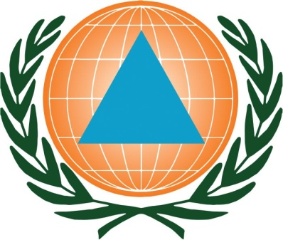
14 | QO2530 | International Civil Defence Organization (英语)  Organisation internationale de protection civile (法语) | Chemin de Surville 10-12  Petit Lancy  1213  Switzerland | 名称 | International Civil Defence Organization
15 | QO2531 | International Civil Defence Organization (英语)  Organisation internationale de protection civile (法语) | Chemin de Surville 10-12  Petit Lancy  1213  Switzerland | 名称缩写 | ICDO

