[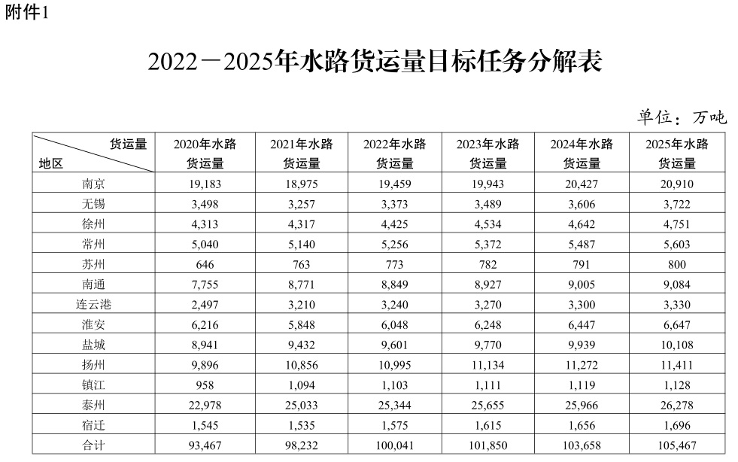](http://www.jiangsu.gov.cn/picture/0/2206301530591139451.jpg)

[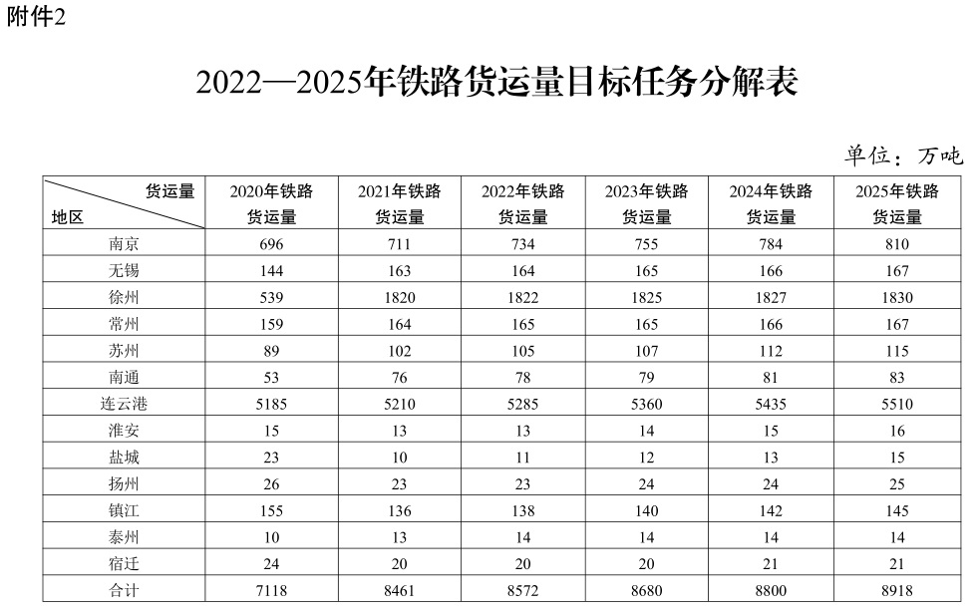](http://www.jiangsu.gov.cn/picture/0/2206301530590953156.jpg)

[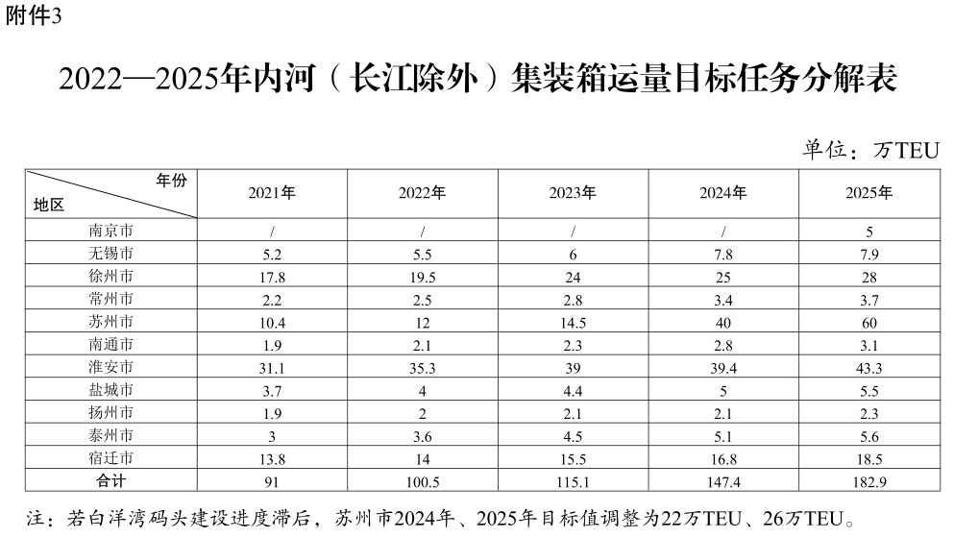](http://www.jiangsu.gov.cn/picture/0/2206301530590796999.jpg)

[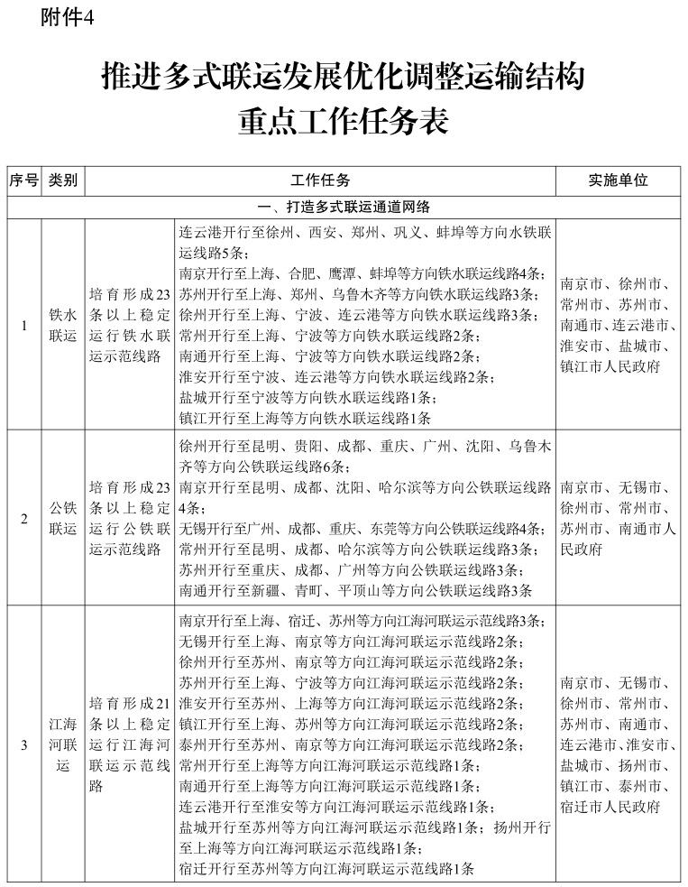](http://www.jiangsu.gov.cn/picture/0/2206301530590608425.jpg)

[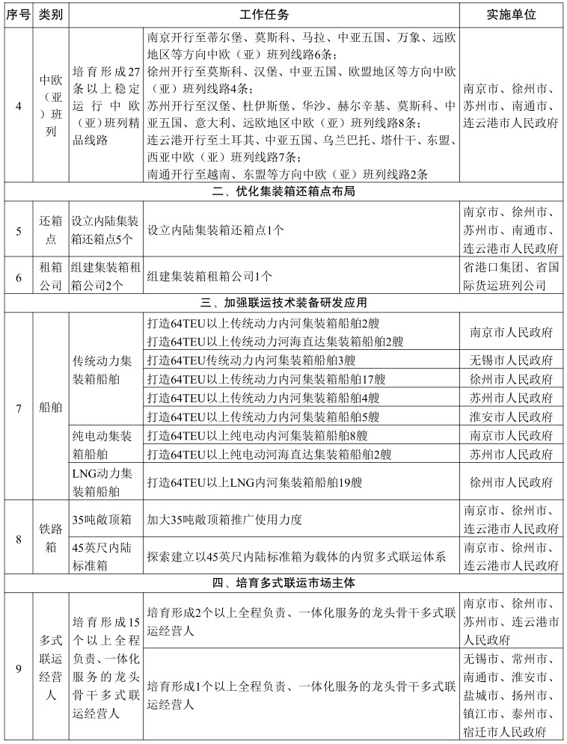](http://www.jiangsu.gov.cn/picture/0/2206301530590419591.jpg)

[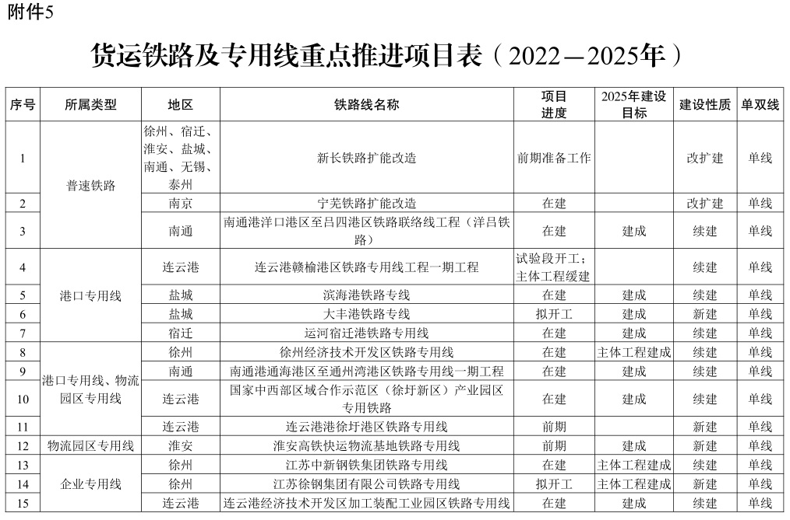](http://www.jiangsu.gov.cn/picture/0/2206301530590249282.jpg)

[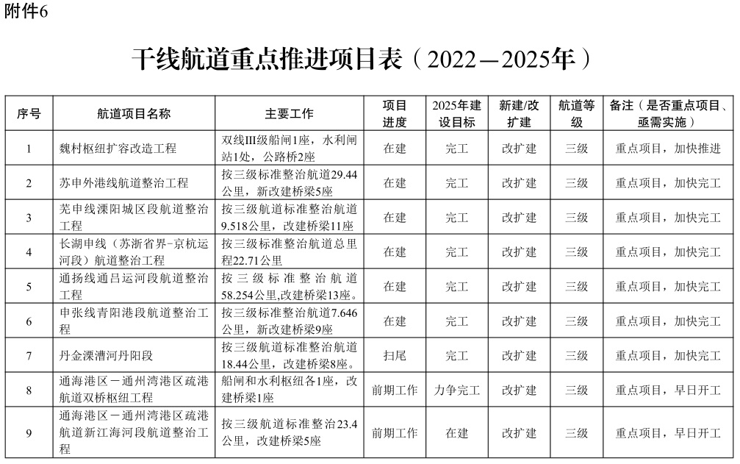](http://www.jiangsu.gov.cn/picture/0/2206301530590053006.jpg)

[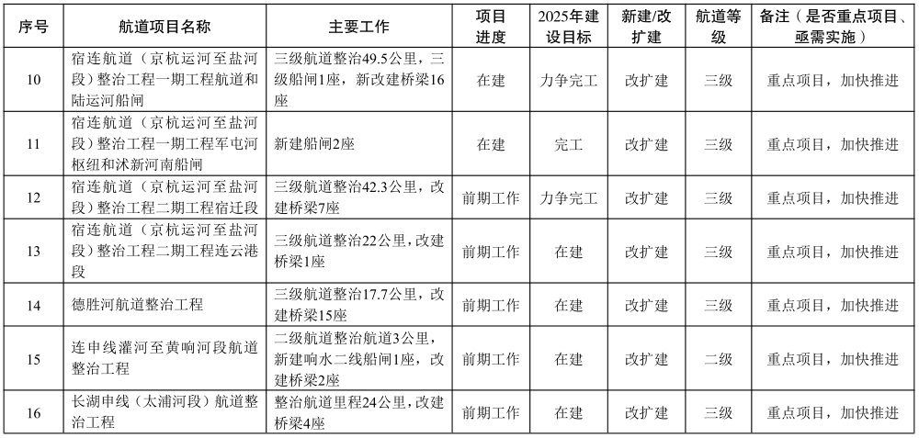](http://www.jiangsu.gov.cn/picture/0/2206301530589895792.jpg)

[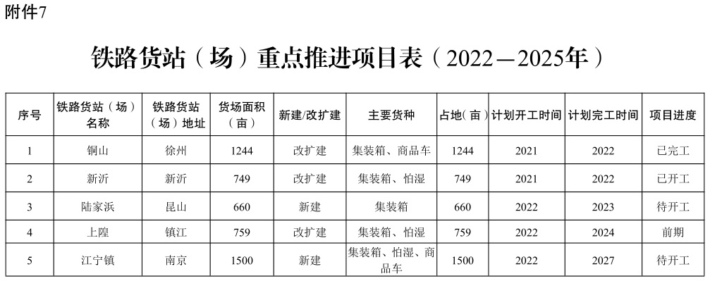](http://www.jiangsu.gov.cn/picture/0/2206301530589717920.jpg)

[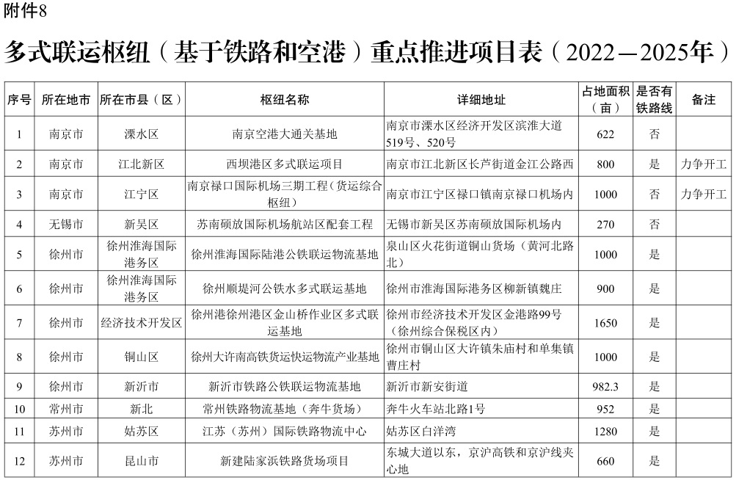](http://www.jiangsu.gov.cn/picture/0/2206301530589454122.jpg)

[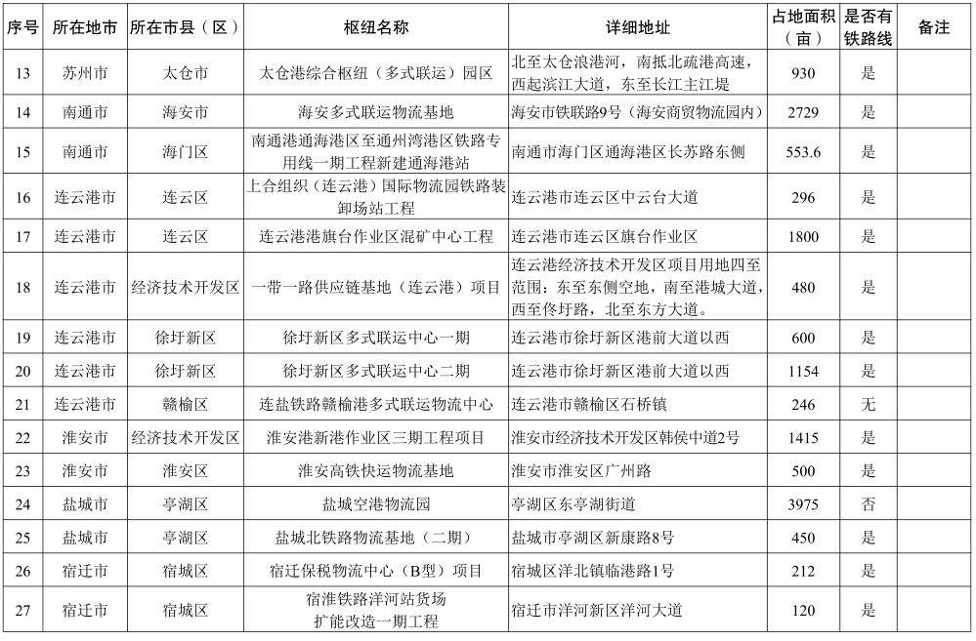](http://www.jiangsu.gov.cn/picture/0/2206301531181507482.jpg)

[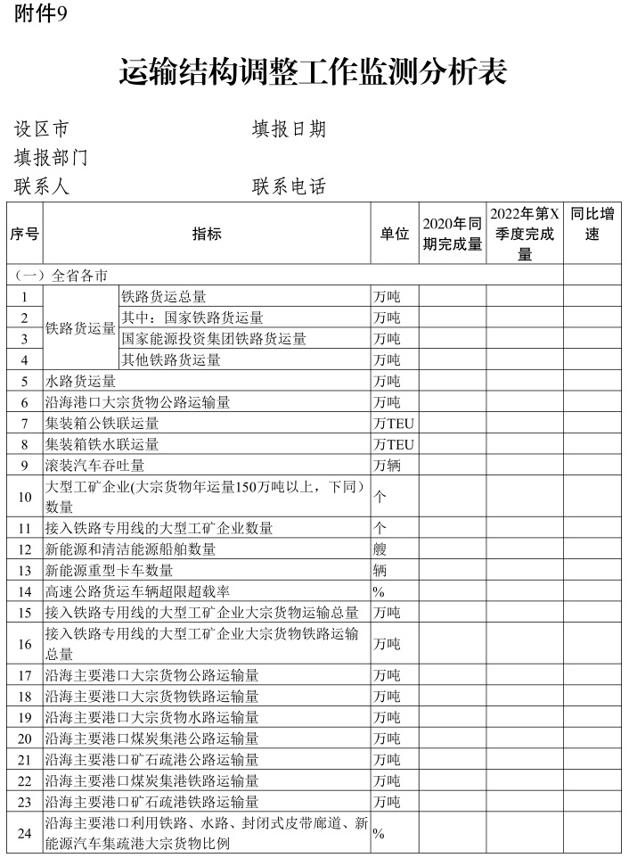](http://www.jiangsu.gov.cn/picture/0/2206301531181298510.jpg)