[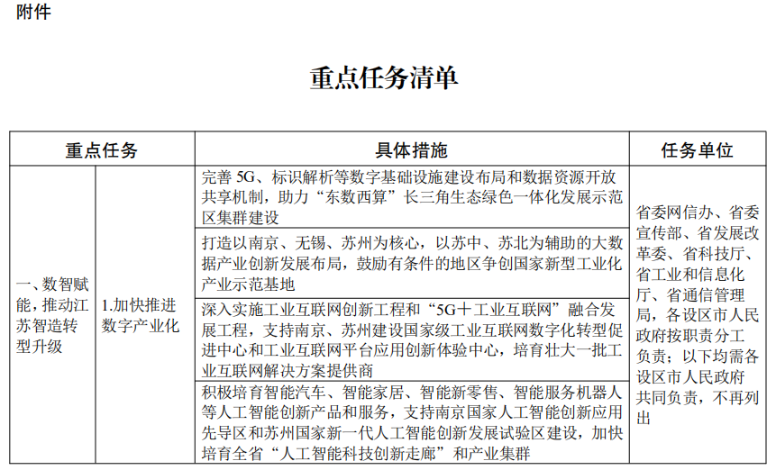](http://www.jiangsu.gov.cn/picture/0/2301061527173899805.png)[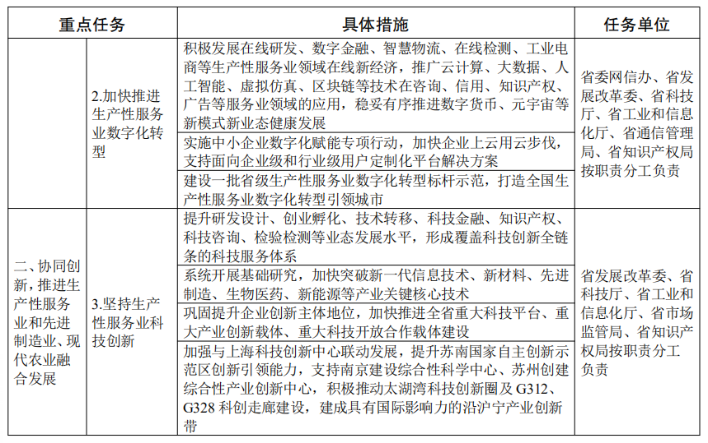](http://www.jiangsu.gov.cn/picture/0/2301061527173728345.png)[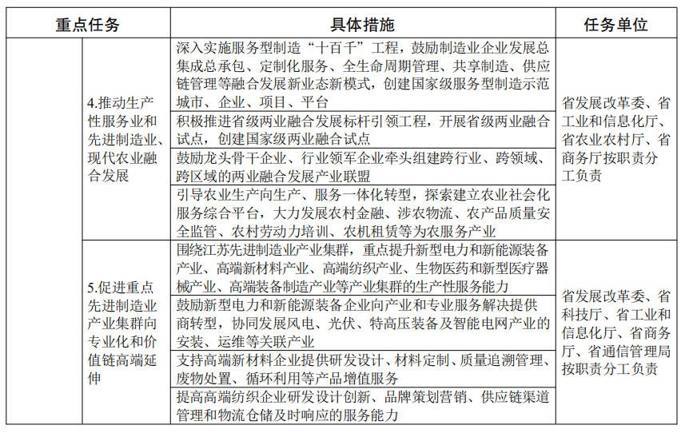](http://www.jiangsu.gov.cn/picture/0/2301061527173528189.png)[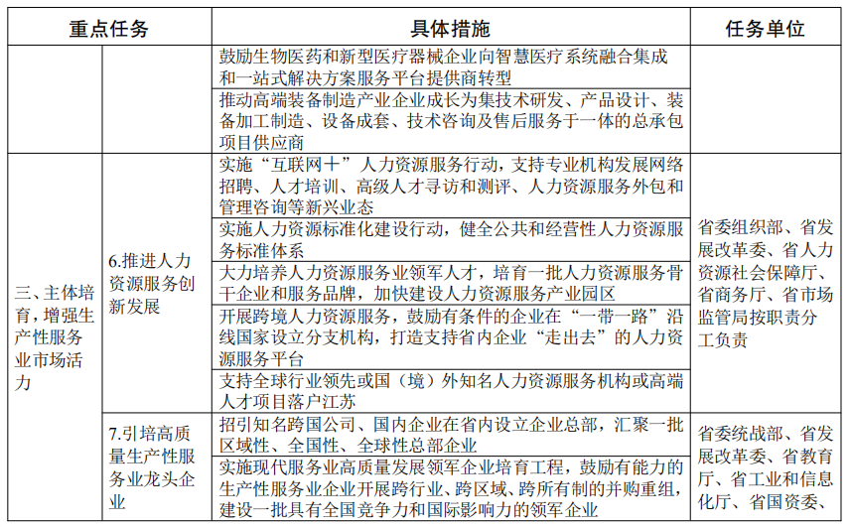](http://www.jiangsu.gov.cn/picture/0/2301061527173359337.png)[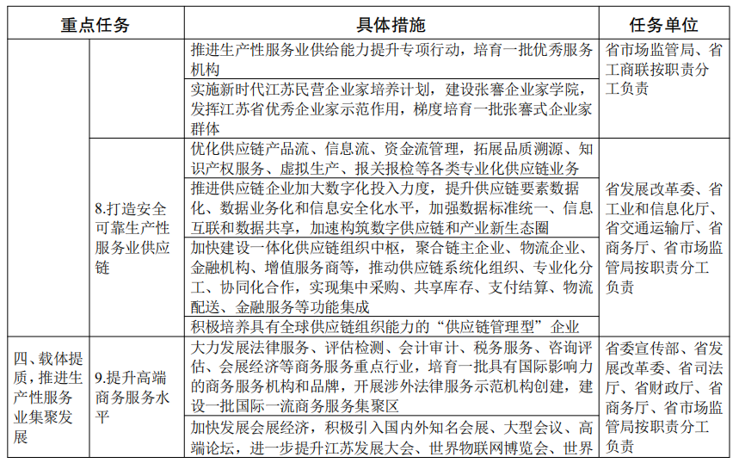](http://www.jiangsu.gov.cn/picture/0/2301061527173191870.png)[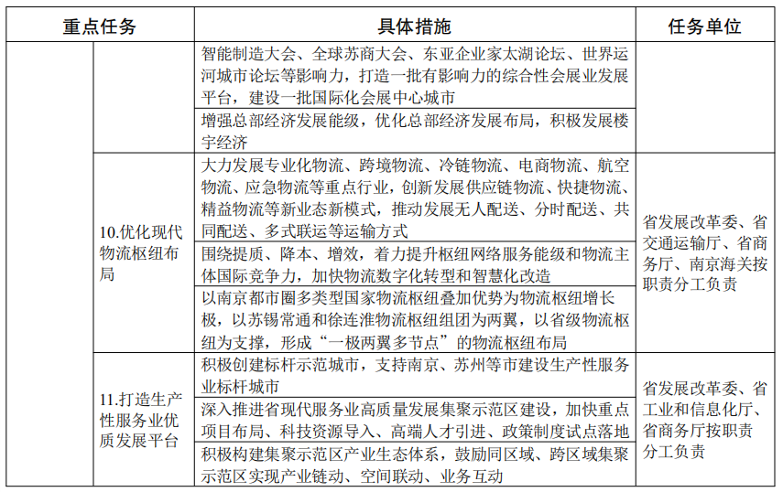](http://www.jiangsu.gov.cn/picture/0/2301061527173002927.png)[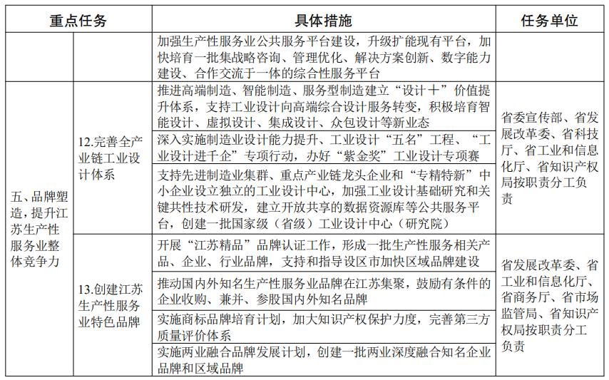](http://www.jiangsu.gov.cn/picture/0/2301061527172855317.png)[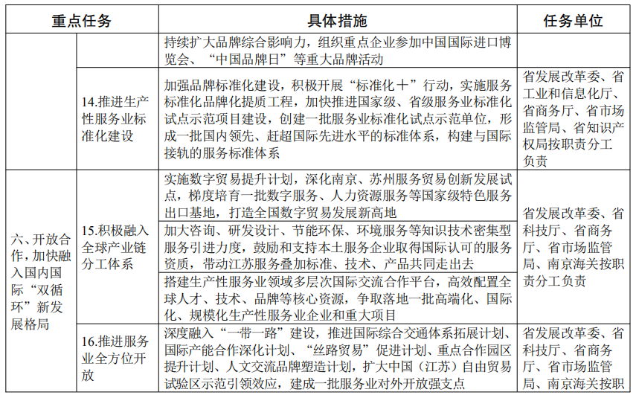](http://www.jiangsu.gov.cn/picture/0/2301061527172687172.png)[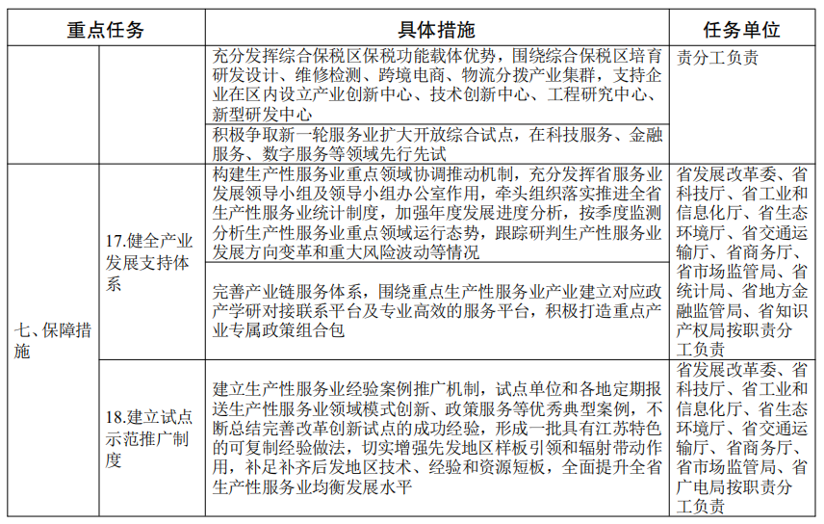](http://www.jiangsu.gov.cn/picture/0/2301061527172529332.png)[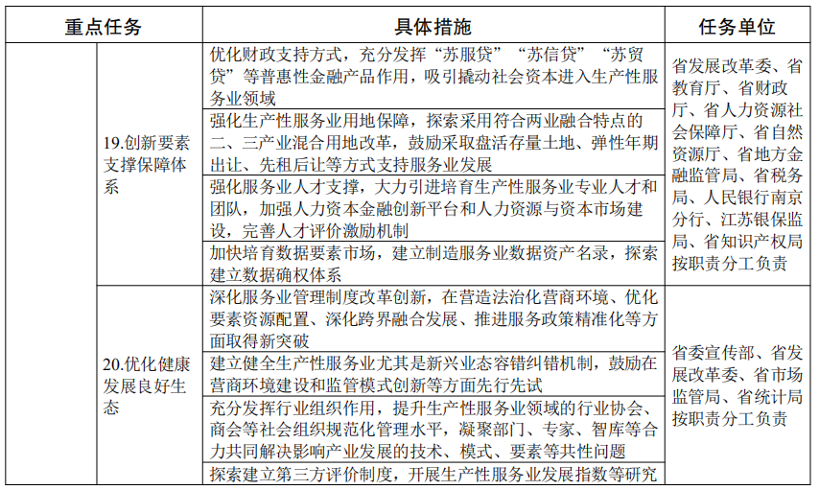](http://www.jiangsu.gov.cn/picture/0/2301061527172303866.png)